**ISDRS OA journal planning**

Draft 27.9.2022

Authors: Marc Wolfram, Sebastian Thomas, Prajal Pradhan, Gyula Zilahy, Sjors Witjes, Pauline Deutz, Janaina Macke

**Contents**

1 Journal market 2

1.1 Demand and competition 2

1.2 Value propositions and USPs 2

2 Scientific profile 3

2.1 Aims & scope 3

2.2 Title 3

3 Publishing formats 5

3.1 Paper types and characteristics 5

3.2 Multimedia formats 8

3.3 Language 8

4 Processes 9

4.1 Editorial board (vs. ISDRS board) 9

4.2 Submission and review process 10

4.3 Conference call and submissions 12

4.4 Social media 13

5 Design 14

5.1 User experience 14

5.2 Branding and marketing 15

6 Technical setup 18

7 Costs 20

8 Work plan 21

NB: Text in blue indicates “discussion not concluded” and/or “next tasks”

# Journal market

## Demand and competition

* *What exactly is the demand for another sustainability science journal?*
* *What are specific and emerging expectations or requirements of our target groups (readers, authors, reviewers)?*
* *What are the most important competitors, and why?*
* SuSc field is growing (Clark and Harley, 2020; Fang et al., 2018)
* SuSc field is small (~10-20) dominated by paywall journals created by incumbent publishers (Elsevier, Springer, T&F, Wiley, Sage)
* MDPI (Sustainability and others) is largely discredited in the scientific community but continues to grow - due to a lack of alternatives
* Few OA SuSc journals have been established or emerged recently: Elementa, Oxford, BMC, PLOS, Librello – but are hardly matching the demand
* The **diversity** of scientific perspectives and approaches in SuSc does currently not find an adequate journal offer for publishing – diversity can in general be expected to receive increasing support through ongoing efforts for a [reform of research assessment](https://research-and-innovation.ec.europa.eu/system/files/2022-07/rra-agreement-2022.pdf) in the EU and beyond.
* Check ISDRS/Wiley agreement for any restrictions; introducing new journal in parallel: agreement may coexist (for continuity) but promotion should focus on own journal

## Value propositions and USPs

* *What distinguishes the ISDRS journal from similar/competing publishing options?*
* *What features make it more/most attractive for our target groups (readers, authors, reviewers)?*
* Diamond OA >> no costs for authors/users, no accessibility constraints
* High scientific quality >> must be ensured from the outset (low acceptance rate …)
* High speed >> fast review and publishing process must be ensured
* SusSci: challenge-driven, strong action/policy/practice orientation >> review criterion, non-tech summary, action recommendations
* Deep inter- and transdisciplinarity >> promote esp. contributions addressing sustainability challenges from multiple perspectives – but also remain open to disciplinary contributions (evolving share)
* Multiple formats: short and long, empirical, deductive and propositive
  + attract output in all stages of the research process
* Link to conference >> easy to move papers from drafts (proceedings) to rigorous journal review and publishing
* Multi-language (counter global research bias i.e. not just for accessibility) >> peer language reviews <https://www.sciencedirect.com/science/article/abs/pii/S0169534721003062>
  + but: reduces citations/ slows down indexing; keeps scholars outside the English science community

# Scientific profile

## Aims & scope

* *What are the scientific objectives the ISDRS journal strives to achieve?*
* *How does the journal support the broader objective of ISDRS to achieve societal change towards sustainability?*
* *What spectrum of scientific contributions are invited? What are the delimitations for this spectrum (out of scope)?*
* We could link the journal with the track so that the journal can help develop the topics by the tracks (see an example of developments in track 1b (book and special issue) as mentioned by Sjors).
* Janaina did an Iramuteq content analysis (see Dropbox/SHARED FILES ISDRS BOARD/Publishing/JOURNAL concept) on the topics of the different tracks at ISDRS 2022. With the track structure used as a base, the journal could take a problem-oriented view.
* Transdisciplinarity (TD) could be an important USP as well as the policy aspect: some academics do not care about implications and have to think about it a bit more. TD and the policy aspect depend on the format of the manuscripts. But “high level” TD could limit the journal, we could focus on at least a policy or recommendation paragraph.
* We could start the journal as inter- and transdisciplinarity-focused with manuscripts ending with practical contributions to the sustainability field. This means specific formats, some require multi-language possibilities, but also how the balance between different academics (for example, PhD candidates and full-grown academics)? For example, early-year academics only should include a policy recommendation, while seniors should substantiate their contribution to society and integrate it into the line of reasoning of the manuscript.

## Title

* *Which title expresses the remit and objectives of ISDRS, its scientific aims & scope, and creates a distinctive and attractive brand?*

Academic and scientific journal titles can be categorised as three main types:

1. Journal of titles: A journal name that includes ‘Journal,’ ‘Proceedings,’ ‘Transactions’ or similar. Examples include the Journal of Business Ethics, Proceedings of the National Academy of Sciences, Transactions of the Royal Philosophical Society, and so on.
2. Topic phrase titles: A journal name that uses one or two key words to describe the research field. Examples include Nature, Science, Sustainable Development, and others.
3. Unique word titles: A journal name derived from a specific and unusual word that has some special relevance to the field. Examples include Ambio, Oryx, Antipode, and so on.

If we adopted the first approach, a suitable journal title would be something like:

* Journal of the International Sustainable Development Research Society (JISDRS)
* Proceedings of the International Sustainable Development Research Society (PISDRS)
* Transactions of the International Sustainable Development Research Society (TISDRS)

Adopting the second approach would mean entering a crowded field but offers the advantage of being able to clearly reflect the nature of the academic content and focus. Examples might be:

* Sustainable Futures
* Sustainability and Development
* Beyond Sustainability

Adopting the third approach means choosing a less obvious but more original name and brand. Examples might include:

* Axia (Greek for ‘value’ or ‘worth’)
* Satata (Sanskrit for ‘continuity’)
* Samaradh (Sanskrit/Hindi for ‘flourishing’ or ‘prosperous’)
* Vigeo (Latin for ‘thrive’ or ‘be vigorous’)
* Evimero (Greek for ‘thrive’)

>> **Suggestion (type 2): Sustainability in Transforming Societies (Subtitle: Journal of the ISDRS)**

# Publishing formats

## Paper types and characteristics

* *Which types of paper formats (text) does the journal offer for authors, and why?*
* *What is the targeted share of these paper types in the journal?*
* *How do we match author output with paper types (or multimedia >>3.2) to optimise impacts?*

The journal should strive to enable diversity also in terms of its formats, catering for outputs in every stage of a research process and embracing diverse disciplinary cultures. Therefore, a range of formats including e.g. research articles, reviews, multimedia and creative contributions, and others is summarised in the table below.

**Journal special features**

We recommend several special features for some contribution formats. These include brief bullet points summarising (a) key insights and (b) and policy or practice implications arising from a submission. These Insights and Implications would be similar to Elsevier’s ‘Highlights’ but align with both wider research translation priorities and the sustainability science focus of the journal.

**Insights**

* 4-5 highlights of the contribution, including at least originality, inter/transdisciplinarity, and key finding/s.
* Presented in English and up to 2 other languages for Articles, Extended Articles, Book Reviews, Features, and Reviews.

**Implications**

* 3-5 key implications for action, policy, practice, theory, and/or research methods.
* Presented in English and up to 2 other languages for Articles, Extended Articles, Book Reviews, Features, and Reviews.

We also suggest that **special issues** could be arranged to accommodate diverse interests and priorities, including (but not limited to):

* Foreign languages
* Different themes (e.g. United Nations calendar events and topics)
* Guest editor/s curated SIs

**Summary**

| **Type** | **Format** | **Word count** | **Process** | **Reviewers** | **Target contributors** | **Description** | **Referencing** | **Frequency** | **Cite rank** |
| --- | --- | --- | --- | --- | --- | --- | --- | --- | --- |
| Article | Manuscript | 5000 | Double-blind peer reviewed | Editor review + senior scholar and PhD candidate or ECR | Post-PhD academics | Original research articles in inter- or transdisciplinary sustainability science that provide novel contributions to evidence bases and/or theory, with implications for action, policy, practice, and/or methods | Preferred maximum 60 references | Per issue | 5 |
| Extended Article | Manuscript | 10000 | Double-blind peer reviewed | Editor review + senior scholar and PhD candidate or ECR | Post-PhD academics | Qualitative, longer-style interdisciplinary social science manuscripts and monographs | Preferred maximum 100 references | Ad hoc | 5 |
| Book Review | Text | 1500 | Invited | Editorial board | PhD candidates and ECRs | Critical discussions of book publications in sustainability science fields that reflect on the book’s contributions to theory, policy, practice, and/or methods | Not required; preferred maximum 10 references | Twice annually | 2 |
| Comment | Text | 500 | Submitted | Editorial board | Anyone | Essentially a ‘letter to the editors’ providing critical and constructive comment on work published previously in the journal | Not required | Ad hoc | 3 |
| Creative | Various | Various | Editorial board review | Editorial board + subject expert | Anyone | Creative works would increase the broad appeal of the journal and leverage its online format | Not required | Ad hoc (minimum 4 issues annually) | 0 |
| Editorial | Text | 1000 | Editorial board review | Editorial board | Editorial board | Editorial board collaborative comment on sustainability science news of the moment | Preferred; not required | Per issue | 1 |
| Feature | Manuscript or video | 6000-8000 words, or maximum 15-minute video, other multimedia | Invited; editorial board review | Editorial board | Senior scholars; sustainability leaders; exciting creatives | High-profile scholarly, creative, and mixed-format works engaging with important contemporary topics to encourage diverse audiences and broad appeal for the journal | Required; format appropriate to content type | Per issue | 3 |
| Multimedia | Podcast; Video; Multimedia only (req. peer review); Multimedia as supplement to manuscript | Various | Submitted | Editorial board (standalone multimedia submissions) or Reviewers assigned to main manuscript | Anyone | Multimedia submissions could be included as supplements to other formats (e.g. webinars or podcasts discussing research findings and implications) or as standalone contributions. | Not required | Ad hoc | 2 |
| Perspective | Manuscript | 3000 | Invited; editorial board review | Editorial board | Post-PhD academics; sustainability professionals | Avenues for research; agenda-setting papers | Preferred maximum 50 references | Per issue | 4 |
| Review | Manuscript | 4000 | Double-blind peer reviewed | Editor review + senior scholar and PhD candidate or ECR | Master’s and PhD candidates and ECRs | Systematic quantitative and qualitative literature reviews to clarify the ‘state-of-the-science’ in relevant sustainability topics | Preferred maximum 60 references (literature review full reference list in separate appendix) | Per issue | 5 |
| Short Communication | Manuscript | 1500 | Editorial board review | Editorial board | Anyone | Focused on work in progress, new projects, snapshot of research programs underway. | Preferred maximum 30 references | Per issue | 1 |
| Viewpoint | Manuscript | 1000 | Editorial board review | Editorial board | Anyone | Scholarly comment and opinion on current affairs, sustainability science implications of major events, environmental happenings, etc. | Preferred maximum 30 references | Per issue | 4 |

## Multimedia formats

* *What kind of multimedia formats does the journal invite, and why?*
* *How does the review and editing process for these formats work, and what quality criteria are applied?*
* *How are multimedia formats linked to papers in the journal (text publications)?*
* *What is the targeted share of these formats in the journal?*
* Video reports
* Webinar presentations
* Creative and artistic media

## Language

* *Which multilingual options/features does the journal offer, if any, and why?*
* *How do we handle multilingual content in the editing and review process?*
* Aim of inclusive multilingual journal: Different communities give access to different knowledge in comparison to the merely western perspective of current journals. For our journal, multi-lingual abstracts could be a possibility.
* Multilingual manuscripts are more challenging, maybe when machine translation is used. Full multi-language will limit citation.
* Highlights could also be multilingual, maybe in combination with the different formats of the articles: for example, up to 3500 words with references and multi-language abstract.
* This has consequences as one reviewer is not enough. Also, the editor should be able to judge the content of the manuscript when parts are in different languages.
* Maybe special issues in local languages (based on Hungarian experiences): for example, short communication that is always available, on annual basis a special issue in a specific language. Plagiarism is also an issue in different languages.
* We should help people that have been publishing to publish in English.
* Because managing multi-languages is complicated: why not offer free translation and use inclusivity in a different way.
* Although international English is becoming more common, having multilingual aspects in the journal is very ambitious also because inclusivity is the main goal of the journal.

# Processes

## Editorial board (vs. ISDRS board)

* *How do we convene and compose the journal editorial board (process, size, expertises)?*
* *How does this relate to the ISDRS board, and to the ISDRS tracks?*
* *How do we select an EiC (or several) and what are the EiC tasks and responsibilities?*
* *What are the tasks and responsibilities of the editorial board members?*
* *What are additional editorial roles, if any, and how are they defined (associate editors, guest editors)?*
* MW: Ed. Board is additional work (esp. initially: develop journal website, communication templates, handling papers, etc.) >> voluntary task for board members to sign up to (independent from ISDRS board tasks);
  + Ed. in chief should *not be a single person* (2-3 m/f), one of which should be a member of the ISDRS exec board
  + Additional subject editors should be recruited to ensure key expertise and coverage, incl. through the tracks (track chairs) to enlarge the board in terms of scope, no. and network
* SW/PD/JM: There is one member of the executive board responsible as editor in chief of the journal, the ISDRS board is the board for the journal, and the main track chairs are the subject editors for the journal.
  + *Discussion*: I agree re editor in chief – and would confirm that I think this person has full editorial rights. They might choose to discuss matters that would impact the Society with exec, but certainly in academic terms the responsibility is with that person (the exec has no say ultimately in what is published).
  + Editorial board – yes I agree would include the ISDRS board. Maybe in time more people would be needed. I think the role of the ed board varies a lot between journals. The Sustainable Devt board has never been consulted on anything during the dozen/15 years I’ve been on it. Other journals provide their editorial board with a budget to attend annual board meetings (eg attached to relevant conference – easy in our case). So we would need to agree what the function of the ed board would be. This is asking more of ISDRS board members who might struggle now to do what they need to do. Likewise, I’m not sure what the role of a subject editor is – aren’t they also on the editorial board? (and what about ISDRS board members who are also track chairs – ie most of them.

## Submission and review process

* *How does the journal attract and invite high quality author submissions?*
* *How does the journal attract and invite high quality editors and reviewers?*
* *What should be the key characteristics of the review process (transparency, number of reviewers, criteria, timeline, editor role)?*
* *How does the review process differ for each submission format?*
* **Pre-submission check:** Before submission is enabled, authors are requested (recommended option) to fill out a very short form *describing their intended submission* (title, topic, approach/method, underlying research project/work: duration, partners; suggested publishing format) >> On this basis editors provide a quick recommendation (within 14d) if authors should submit (aims & scope) and in which format.
* *Benefit: Risk management for authors; Submissions received are well aligned with journal profile, quality criteria & format requirements; avoidance of ex-post format changes in the review process, reduced no. of rejections*

**General review and decision procedure** (important: communicate flexibility regarding timeline for reviewers):

1. Quick check from editor on pre-submission
   1. Reject the request
   2. Invite for submission
2. Manuscript submission (with possibility of preprint?)
3. Basic quality check by the journal office (include a check-list during the submission)
4. Quick screen for suitability by Editor-in-Chief(s)
   1. Reject manuscript
   2. Assign manuscript to a section editor
5. Screen manuscript by section editor
   1. Reject manuscript
   2. Assign manuscript to an editor
6. Scan manuscript by an editor
   1. Reject manuscript
   2. Assign reviewers
7. Secure at least two/three reviewers (21 days for review)
   1. Reject manuscript
   2. Revise manuscript
   3. Accept manuscript
8. Revision by authors (21 days)
9. Production of the accepted manuscript by the journal office (print of just accepted manuscript?)
10. Promotion of potential impactful article by editors and journal office, including blogging.
11. Invite a **reviewer** **to write a related short contribution** (e.g. Viewpoint) on potential impactful article

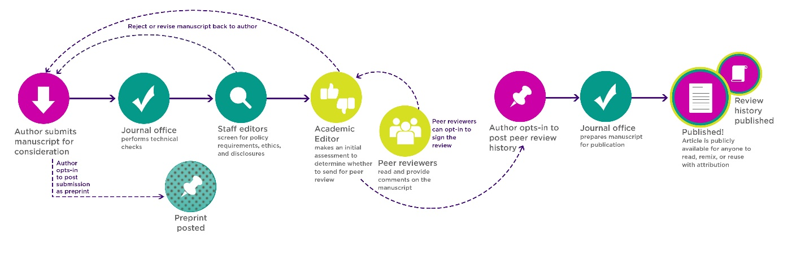

Source: <https://journals.plos.org/plosone/s/editorial-and-peer-review-process>

* MW: Finding good reviewers is a major challenge for all journals. While the number of both journals and papers continues to grow, reviewers don't multiply ... still their role remains highly undervalued and invisible. Tackling this would be really crucial to manage the quality and speed of the journal. In order to make the reviewers an integral part of the journal ecosystem we could:
  + Draw on the track chairs and their respective networks: ISDRS has the advantage of already having a community/network i.e. liability/trust are slightly higher here
  + Invite authors from the journal *by default* as reviewers (incl. for special issues);
  + Support reviewer visibility by default (next to the article e.g. https://www.frontiersin.org/journals/sustainable-cities), or on a reviewers page (like the editorial board page), create small incentives (e.g. a fee discount, or at least a side event at the conference), and esp. explicit recognition (e.g. top reviewers award) and offer paths from reviewer to editor (guest or board)
* GZ: The speed of dialogue between scientists (long publication processes and again the long time to publish any reaction) may have been appropriate a few dozen years ago, but today, with real time internet in our pockets, this is definitively out of date. One way of accelerating this could happen through the journal website, which could facilitate discussion better than traditional journals since there will be no print version. Another way, we could facilitate this is by inviting the best reviewer of each accepted manuscript to submit a one page ’note’ discussing the transdisciplinary and/or policy (or some other) aspects of the paper, which we would publish next to the original article with appropriate credits to the reviewer. The benefits of this would be:
  + For the authors: they would know that a proper, high quality note will discuss the policy/transdisciplinary aspect of their article, so they will take these aspects more seriously
  + For the reviewer who prepares the note: with a little bit of extra effort (they already know the manuscript) they will gain visibility for their contribution to the journal
  + For the subject editor: a bit of additional work of editing the ’note’, but easier collection of reviews and probably better quality reviews
  + For the journal: a chance to promote dialogue and put the article in a broader/different context, which may or may not have been addressed by the original authors
  + For ISDRS: facilitating dialogue, which is the main objective of the annual conferences and of the Society in general.
* We should take a constructive approach with early career, and PhDs as reviewers. We enable the engagement and communication between the reviewers throughout the review process by adding formats that enable publication of research on the go and provide consecutive approaches to different kinds of researchers. We should also be open to more dialogue formats: open up for a wider discussion.
* PD: Speeding up the publication process would be useful (though not by leaning on reviewers to respond in 2 or 3 weeks), and some sort of debate might be good, but I have some misgivings. 1) Reviews won’t be anonymous. 2) It adds to both the reviewers’ and editors’ workload. 3) There’s a risk of proliferation of publication types, which I can see is the idea, but nonetheless will create issues as to how and for what purposes they are cited. My concern is a separation of ideas and evidence supporting them. The traditional research article is a blend of theoretical developments and empirical evidence in support – as we know. And that does take time to do to a high standard. We aren’t journalists – trying to respond instantly to what is happening. If the academic publication process is sped up by previewing the ideas, this could devalue the eventual bone fide research. You might end up with lively but vacuous debates; alternatively people might use the ideas to drive their research but think that a non-trad article doesn’t need citing. Or others will cite the idea paper and ignore the subsequent evidence – I’ve seen this happen. People cite an early paper from a project I was involved in, which sets out the propositions of the project. They use that to paper claim they are doing something original, whilst ignoring five later papers that have thoroughly addressed the issue. Of course there is always another angle, but it’s already too easy for people to be strategic in citing (including those taking a ‘systematic’ approach).

## Conference call and submissions

* *How are the conference call and submissions connected to the journal?*
* *What is the relation between the conference proceedings and the journal?*
* MW: The journal should be a stand-alone product attracting contributions from sustainability scientists globally – the conference is only an “insurance” for achieving critical mass and coverage quickly, also re indexing (regular and diverse global input min. 30 papers p.a.)
  + Conference submissions do not enter journal review by default - 1) authors of full articles should indicate interest in journal review and publication (otherwise: proceedings); 2) Conference reviewers should assess if the article is suitable for the journal (replaces pre-submission check)
  + Replacing Oxford Abstract with an OA platform for conference mgmt. (e.g. Indico) would enable seamless transfer of submissions and reviews from conference to journal
* SW/PD/JM: As the responsibility of the different subjects of the journal is being taken by the track chairs, the review task can be divided within the track or among the authors of the abstracts for the conference or, we could use the early career researchers group/PhD students to review in the supervision of the track chairs.
  + *Discussion*: For a special issue recently completed, we had the authors review each other’s papers. There was some goodwill for this, they all were timely (some range in the quality of reviews, but that’s a different matter). Other than special issues, there’s not such a readily identifiable group of potential reviewers. I guess that track chairs would go to the community they know, which would include ISDRS regulars. We can hope for some goodwill, but I expect it’ll be a challenge to find reviewers (we could complicate things by offering a conference discount of X number of reviews in a year? – though that is exploiting people short of cash to do work that others manage to avoid).
* SW/PD/JM: The call for papers for the journal is directly linked to the call for abstracts for the ISDRS conference and is being managed by the track chairs.
  + *Discussion*: I’m not sure about tying this too close. Are you seeing the journal as replacing the proceedings? (I think not, as the lower standard for publication in the proceedings seems to have benefits as helps people to get funding for the conference whilst work is in progress). We would encourage papers to be submitted for the journal, but I think this would be a separate step to submitting an abstract/paper for the conference.
  + I assume the journal would happily consider papers that have not been presented at the conference? This is partly for variety and to increase readership, but also to get a flow of papers through the year.

## Social media

* *Which social media channels does the journal incorporate, and why?*
* *How do we provide for content management and the required regularity, frequency and resonance of posts?*
* *What are the workflows needed to support this?*

# Design

## User experience

* *What design features enable to best meet user needs and the journal’s functional/procedural requirements?*
* *What design features are required to ensure web accessibility?*

* **Design simplicity**: A lean and attractive design interface will ensure ease of access across diverse digital platforms and bandwidths. We feel the Nature journals offer a good example of this model.

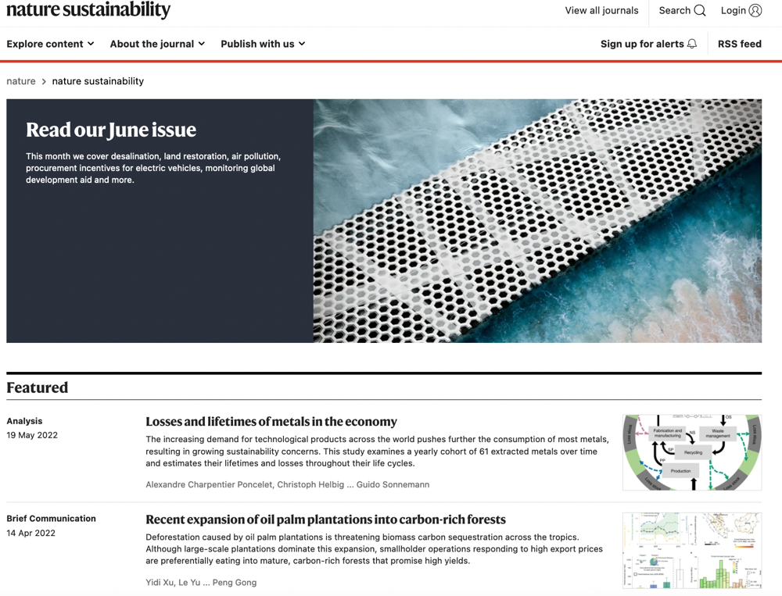

* **Ease of use and CX**: This is the customer experience (CX) aspect and relates to limited menus with easy-to-navigate pathways through the online journal website.
* **Modern approaches to content, media, and user interaction**: Rather than translating a tradition paper journal into a digital format, or having an excessively busy website, like this:

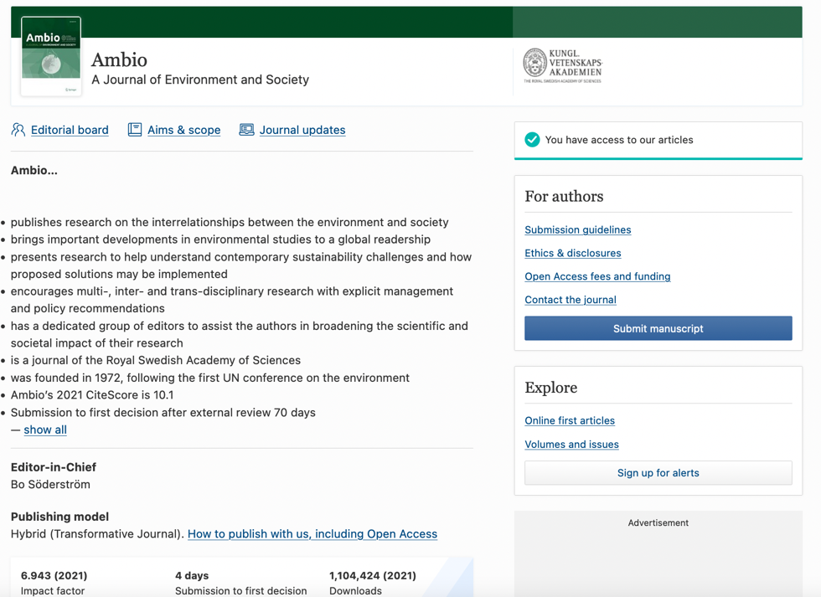

* We suggest building an interactive and engaging site that meets academic needs and appeals to scholars and others from digital native generations.



* While options may be constrained by the hosting platform, we advocate for a design that leverages the opportunities provided by a digital platform.

## Branding and marketing

* *What web design features best express the journals title, aims and scope?*
* *What web design features provide for a highly attractive and professional journal interface?*
* *What other means for journal marketing should ISDRS implement (i.e. beyond website and social media)?*
* We propose developing a branding palette of colours and a unique logo (with supporting graphic icons). This should be informed by the discussions around the journal concept including USPs. We can also discuss whether to employ a professional designer although our sub-group can mock up some initial ideas based on discussions.
* These are examples of how palettes and designs might be presented for use.



# Technical setup

* *What are the technical and management features required for journal set-up?*
* *How do we provide for the most advanced features at the lowest possible cost?*
* OS software platform Open Journal System (OJS) - best/most used solution available (+25k journals worldwide)
  + Supports all workflows from paper submission to review and publishing
* Saxon State Library (SLUB) offers journal **set-up, hosting and key support services for free** (e.g. indexing - see details: Dropbox/SHARED FILES ISDRS BOARD/Publishing/JOURNAL set up and planning)
  + SLUB is a leading player in developing a nationwide OS publishing house in Germany
  + Current offer only applies to members of Saxon universities and research institutes (MW)
* Standard **website templates** enable all basic journal functionalities and a contemporary frame-based design. *SLUB is committed to purchase and tailor a template according to ISDRS priorities for free*.
* Further **extension of functionalities via plugins** (specific functions e.g. social media feeds, diverse journal metrics, ORCID) can be agreed with SLUB
  + Complete list of all existing plug-ins not available (cf. list of selected plugins: Dropbox/SHARED FILES ISDRS BOARD/Publishing/JOURNAL set up and planning)
  + Allows tailored and transparent handling of journal metrics (external/internal) *independent from Clarivate* *et al.*, e.g.: No. of citations; Citing papers; No. of views; No. of downloads; No. of submitted articles; No. of accepted articles; Days from submission to acceptance
  + Only new and unusual plugins would require development work (costs)
* **Workflow**: Submission and review based on Word templates (handled as PDF)
  + Shift towards full XML workflows is under way: enables more flexibility between formats and automated text processing (e.g. HTML already available for article display)
  + OJS also supports handling multimedia formats – no experiences available at SLUB yet, currently testing performance
* **Design**: Shaping an attractive, unique and professional appearance requires involving a website designer for the first conception and layout (see costs below)
* SLUB is currently reviewing the possible **integration with OS conference mgmt.** platform Indico (CERN) <https://getindico.io/> >> Indico could replace Oxford Abstracts - would enable seamless workflows between conference and journal for paper handling (and save costs for Oxford Abstracts).

# Costs

* *What are the principal cost factors for setting up and running the journal?*
* *What are reasonable cost estimates for these factors (over time)?*
* *How can ISDRS cover the resulting costs through its current income (and people involved)?*
* *What additional staff positions are needed for certain tasks, and how/where do we create these?*
* *What are potential additional income options (linked to the journal)?*
* No costs involved for technical set-up and hosting (if covered by SLUB)
  + Tailored plugins (if any): 1x initially (costs depend on our requirements)
  + Need to check alternative collaboration options at other universities
* Website design: **1x initially (~2-3k€)**
* Operating costs: Journal office (50% position) - largely depend on location (salary levels EU28 **~6-18k€ annually)** for:
  + Communication (editors, authors, reviewers)
  + Layout and typesetting check
* Cost coverage: based on membership and conference fees; need to additionally explore a) subsidies for OA publishing, b) private sponsorship, c) crowdsourcing
  + Operating costs are not a limiting factor initially (~20-30 papers p.a.) but will increase with journal growth (no. of submissions)
  + Possible cost savings: using OJS & OA conference mgmt. (e.g. Indico) instead of Oxford Abstracts

# Work plan

* *What are the different tasks for practical journal set-up, and what timeline and resources do they require?*
* *What are key milestones for journal set-up (decision making, deadlines), and how do we coordinate the set-up process?*
* **Governance and organisational set-up** incl. decision making in ISDRS board and aligned with conference planning (until 03/23):
  + Convoke journal management team
  + Include journal in ISDRS governance
  + Convoke editorial board
* **Journal conception and workflows** needs to be finalised in time for conference (until 07/23)
  + Aims & scope
  + Formats
  + Submission and review process (communication templates etc.)
* **Marketing and dissemination** 
  + Develop strategy and tools for launch period 2023/24
  + Commission key contributions for 1st edition
  + First public announcement at conference (07/23) >> include selected submissions for 1st edition
* **Technical set-up** **and design** – interdependent with the tasks above, requires several net months esp. for
  + website tailoring (template, plugins)
  + website design (layout, graphics)
  + registrations (e.g. eISSN, DOI, etc.)
* **Journal launch 06/24**

*Overview: Journal development and implementation work plan 2022-24*

